Advanced Algebra Name: ______________________
Quiz 7.3-7.4 Period: _____

For problems 1 – 2, let f(x) = and g(x) = . Perform the indicated operation and state the domain.

1. f(x) + g(x)
answer: __________
domain: __________

2.
answer: __________
domain: __________

For problems 3 – 4, let f(x) = x² + x – 1 and g(x) = 2x. Perform the indicated operation and state the domain.

3. f(x) – g(x)
answer: __________
domain: __________

4. f(x)g(x)
answer: __________
domain: __________

For problems 5 – 8, let f(x) = 3x ⁻¹ and g(x) = x – 8. Perform the indicated operation and state the domain.

5. f(g(x))
answer: __________
domain: __________

6. g(f(x))
answer: __________
domain: __________

7. f(f(x))
answer: __________
domain: __________

8. g(g(x))
answer: __________
domain: __________

For problems 9 – 10, verify that f and g are inverse functions.

9. f(x) = 2x – 3, g(x) = x + 10. f(x) = , g(x) = x³ – 1

For problems 11 – 13, find the inverse function.

11. f(x) = x + 8 12. f(x) = 2x⁴, x 0 13. f(x) = -x⁵ + 6

For problems 14 – 16, graph the function f. Then, use the graph to determine whether the inverse of f is a function, circle yes or no.

14. f(x) = 3x + 2 Yes or No 15. f(x) = -2x² + 3x – 1 Yes or No

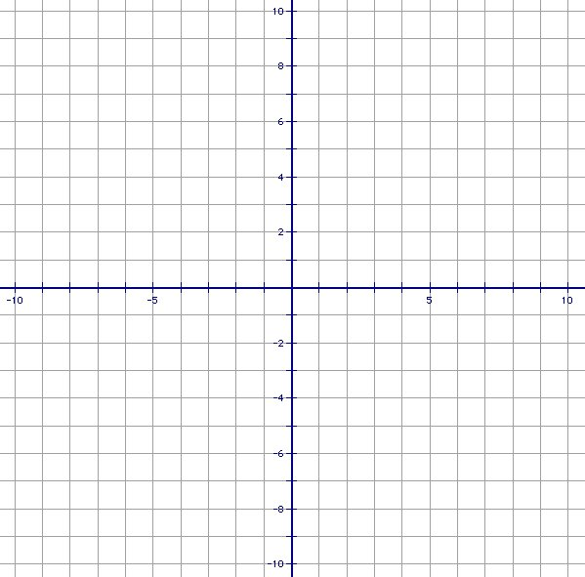

16. f(x) = Yes or No

For problem 17, find what is needed.

17. The volume of a cylinder with height 10 feet is given by V = 10r², where V is the volume and r is the radius. Write the inverse model that gives the radius as a function of the volume. Then determine the radius of a cylinder given that its volume is 1050 cubic feet.

inverse: __________

radius = __________

